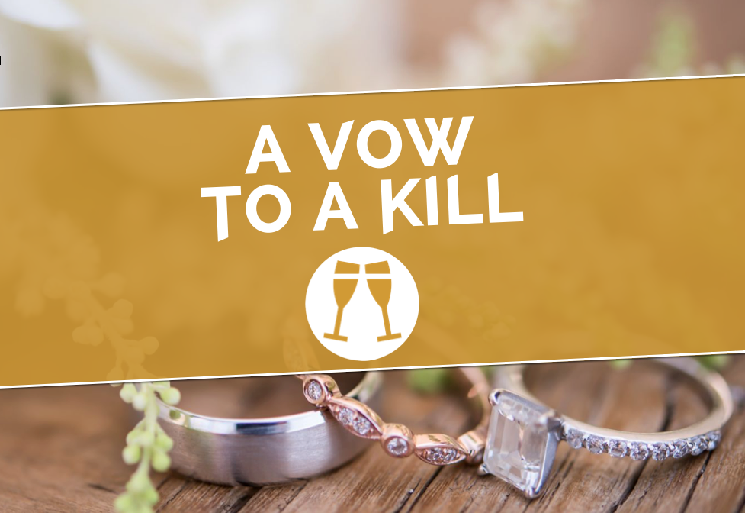

#WHOKILLEDBEAUKAY
PLAYERS RACE ROUND READING TO CATCH A WEDDING
KILLER IN MURDER MYSTERY TREASURE HUNT THIS SUMMER

Saturday 28th July, Saturday 4th August & Saturday 11th August.
Running at 12pm and 3pm. Tickets £22 from www.avowtoakill.com

The team behind A Shot In The Saddle and A Dish To Die For are back with a brand new Murder Mystery Treasure Hunt for Reading this Summer in A Vow To A Kill. Prepare for a glorious summer wedding - with a killer twist. A new, 3 hour immersive treasure hunt, A Vow To A Kill challenges teams of intrepid detectives to race round Reading, search the streets for hidden evidence, crack cryptic clues and catch a wedding killer, all against the clock – as players must get back to the church on time!

Reading becomes the set for this Summer wedding in a real-life whodunnit, which combines the best bits of the crystal maze, escape-room style puzzles, a scavenger hunt and live actors with a murder mystery, as players must crack cryptic clues using their smartphones, converse with suspicious characters and find vital evidence hidden around the town, in partnership with local businesses and iconic Reading locations!

The game centres around the wedding of celebrity supermodel, Beau Kay, who was due to get hitched in Reading. But during the rehearsal for her big day, as she practised her wedding vows, someone else tied the knot - around her neck. Scotland Yard’s reputation is on the line - and they need your help.

Back with their fifth mystery, creators Richard Alexander and Alex Farthing are still in shock at how popular they are: “When we wrote A Gamble With Death less than 12 months ago, we could never have imagined that one year later, we’d be coming back with our fifth mystery! The public have been so amazingly supportive – it spurs us on to come up with even more dastardly plots!” Perfect for friends and families, teams or individuals, players across the four previous mysteries have also enjoyed an unexpected workout, collectively walking over 2,100 miles between them – and discovering hidden Reading gems along the way!

A Vow To A Kill runs at 12pm and 3pm on Saturday 28th July, Saturday 4th August & Saturday 11th August. Tickets are £22 from www.avowtoakill.com. Find us online on all social media using #WhoKilledBeauKay.

-ENDS-

For further details please contact Richard or Alex on press@avowtoakill.com

